# Jones Assignment part 2

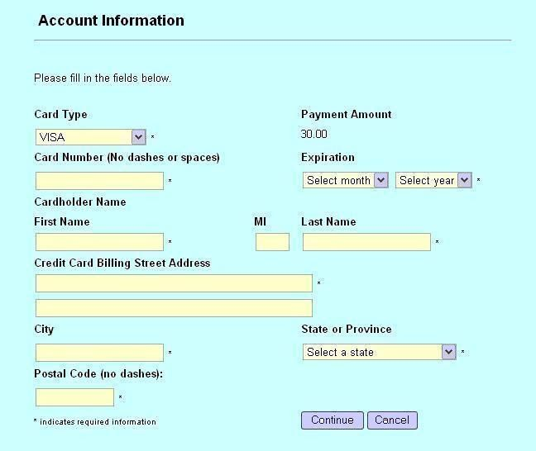

1. The amount of payment doesn’t say which currency its in
2. The MI section doesn’t stand for something familiar and not helping (maybe middle name – but not big enough or aligned with other fields. Nevertheless, its capitalized instead of saying its middle name or what it stands for.
3. The credit card billing street address isn’t clear about the length and the content that is supposed to be at this section.
4. There is no security check mark for the payment
5. Maybe a drop down menu once of the city field once the state is chosen.
6. The field name should be with more spaces – as in card holder name – should have more space under the credit number input field.
7. I think the credit card billing address shouldn’t be that big and doubled – because It contains only street address and a number
8. The indication of required fields of info should be sticked to the field’s name, and not the text field to make it more clear
9. I would also improve the usability by changing the fonts and underline the fields name and add colon after. Also I would move the buttons a little to the right towards the edge of the page.
10. Change the credit card billing address to only billing address
11. The topic says account information but does not only contain personal details but also credit card – so I would add it to the topic as “Account and credit card information”